**YEAR: 7**

**2023**

**SUBJECT: Science**

**Semester 2 Term 3**

TEST: Chemistry (Mixture)

**Marking Key**

TIME: 55 minutes

QUESTIONS:

**12 Multiple Choice (12 marks)**

**10 Short Answer (28 marks)**

**DO NOT WRITE ON OR MARK THIS PAPER**

## SECTION ONE—MULTIPLE CHOICE (12 marks)

This section has **12** questions. Answer **all** questions on the separate Multiple-choice Answer Sheet provided.

1. Which one of the following substances is a mixture?
2. Table salt
3. Seawater
4. Gold
5. Oxygen
6. Sugar dissolves easily in water, therefore sugar is said to be:

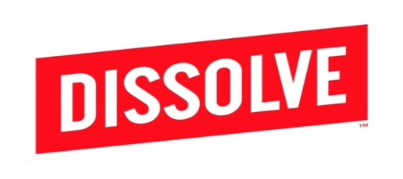

[This Photo](https://www.finsmes.com/2013/09/dissolve-raises-5m-funding.html) by Unknown Author is licensed under [CC BY-NC-ND](https://creativecommons.org/licenses/by-nc-nd/3.0/)

1. insoluble
2. a solution
3. solvent
4. soluble
5. A solid which dissolves in another substance is called a:
6. Sediment
7. Solution
8. Solute
9. Solvent
10. Which of the following is incorrect? An insoluble substance may:

a) Form a solution

b) Float on top of a liquid

c) Form a sediment

d) Form a suspension

1. Decanting is:
2. Pouring liquid from a beaker or flask down the sink
3. Pouring the entire contents of one beaker into another more conveniently sized beaker
4. Tipping a liquid into a filter paper sitting in another beaker
5. Tipping the liquid in one beaker into another, leaving some solid in the bottom of the first beaker

6. Choose the statement that describes the filtration of muddy water.

a) Mud is retained on filter paper and is called filtrate

b) Water passes through filter paper and is called residue

c) Water passes while mud is retained on filter paper

d) Water is retained on filter paper and is called filtrate

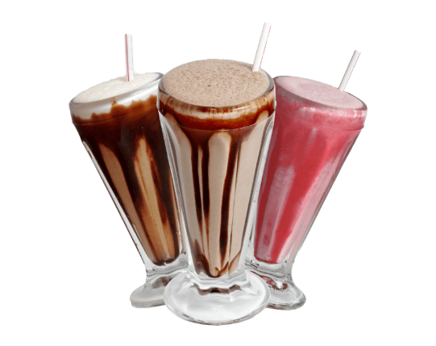7. One way to make a milkshake is to add flavouring to milk. To make this type of milkshake more concentrated, you should add more:

a) Whole milk

b) Reduced-fat milk

c) Sugar

d) Flavouring

8. Which mixture could be separated using magnetic attraction?

a) Nails and paperclips

b) Iron filings and sulfur

c) Iron filings and paperclips

d) Sand and sulfur

9. What is the name of the process used by cooks to separate large grains from small particles?

a) Filtration

b) Sedimentation

c) Sieving

d) Simple separation

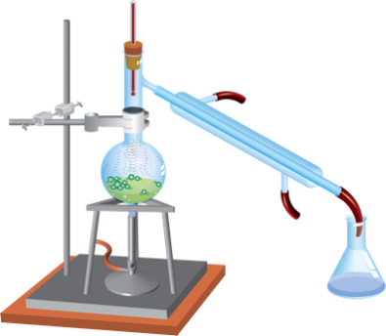10. Which method of separating different substances in a mixture, is shown below?

1. Simple separation
2. Chromatography
3. Filtering
4. Distillation

11. Inks can be separated into their coloured components by:

1. Distillation
2. Crystallisation
3. Filtering
4. 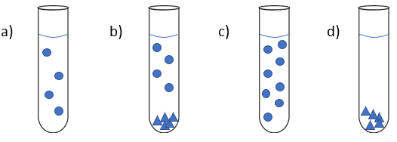Chromatography

12. Which diagram represents a saturated solution?

= dissolved solid particle

= undissolved solid particle



**SEMESTER 2 2023**

**Mixtures Test:**

**ANSWER BOOKLET**

**Marking Key**

**NAME:** _____

**FORM:** **DATE:**

Multiple Choice Short Answer Total

**/28**

**/12**

**/40**

**SECTION ONE:** Multiple choice answers

Cross (X) through the correct answer.

|  |  |  |  |  |
| --- | --- | --- | --- | --- |
| **1** | a | b | c | d |
| **2** | a | b | c | d |
| **3** | a | b | c | d |
| **4** | a | b | c | d |
| **5** | a | b | c | d |
| **6** | a | b | c | d |
| **7** | a | b | c | d |
| **8** | a | b | c | d |
| **9** | a | b | c | d |
| **10** | a | b | c | d |
| **11** | a | b | c | d |
| **12** | a | b | c | d |

**SECTION TWO: Short Answer (28 marks)**

|  |  |
| --- | --- |
| **MUST STATEMENT**  Describes techniques for separating given materials from a mixture. Identifies pure substances and mixtures from given examples. | **MUST QUESTIONS**  1, 2, 3, 4, 5, 7, 8, 9, 10, 11, 13, 14, 15, 16 |

**Answer the questions in the spaces provided.**

1. Define the following terms:
2. Pure substance (1 mark)

A single substance that is on its own (1) Can not be separated by physical separation techniques or other acceptable answer.

|  |
| --- |
| Accept ‘substance’ in answer. Don’t accept ‘element’, as compounds can be pure substances. |

1. Colloid (1 mark)

|  |
| --- |
| a homogeneous substance consisting of large or small particles of one substance dispersed through a second substance (1) A mixture that always looks cloudy because insoluble particle remains suspended throughout or other acceptable response |

1. Simple separation (1 mark)

|  |
| --- |
| method that converts a mixture of chemical substances into two or more distinct products (1) or Separating large particles by hand etc. |

1. Read the following statements and answer the following questions:

Wax is a solid that does NOT dissolve in water.  
Wax does dissolve in kerosene.  
Sugar does dissolve in water.  
Sugar does NOT dissolve in kerosene.  
Kerosene does NOT dissolve in water (3 marks)

1. **Identify** the solvent you would use to make a solution containing wax.

Kerosene (1)

1. **Identify** two substances that are insoluble in water.

Kerosene & Wax (both for one mark - 1)

1. I**dentify** a substance that is soluble in water.

Sugar (1)

1. List two examples of filtering or sieving used around the home. (2 marks)

Example 1: __________________________________________

Example 2: __________________________________________

Examples can include cooking, tea bags, car application etc. (1 mark for each)

1. Evaporation is a technique used to separate substances.
2. Give an example of a mixture where evaporation is used to separate substances. (1 mark)

|  |
| --- |
| Any reasonable mixture including salt water, muddy water etc. (1) |

1. Draw a labelled diagram using correct science skills of the equipment you would use in evaporation. (4 marks)

|  |
| --- |
| Uses Pencil (1/2 mark) Uses ruler (1/2 mark)  Correctly labels equipment (1 mark)*  Correct equipment (1 mark)*  Equipment drawn correctly (1 mark)*  *half marks for partial answers. |

|  |  |
| --- | --- |
| **SHOULD STATEMENT**  Selects and describes appropriate separation techniques based on the physical properties of a number of components of a mixture. Explains the difference between pure substances and mixtures. | **SHOULD QUESTIONS**  6, 12, 15, 17, 18, 19, 20 |

1. Your little sister is watching you put a teaspoon of sugar into a glass of hot water. She makes a comment that ‘the sugar has disappeared”. How do you explain the “disappearance” of the sugar to her? (2 marks)

|  |
| --- |
| Sugar has dissolved (1) process which causes sugar to dissolve such as molecules broken down to smaller parts etc. (1) |
|  |
|  |

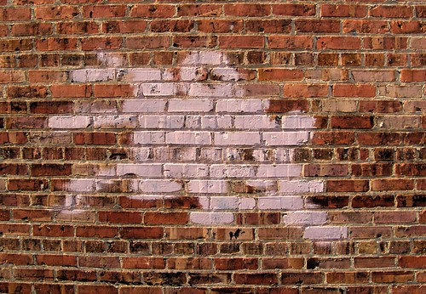

1. Graffiti can be covered with oil-based paints, the oil is most commonly linseed oil. Is the paint the: a) solvent b) solute or c) solution? **Explain your answer**. (3 marks)

|  |
| --- |
| Paint is solution (1) |
| Linseed oil is solvent (1) |
| Colours / pigments is solute (1) |
|  |

1. In gold panning, a mixture of gravel and gold particles are swirled around in water and the gold remains in the pan while the gravel is swirled out into the river with some of the water. **Name** and **explain** this separation method. (2 marks)

|  |
| --- |
| This is a method of filtration (1), (then one of ) separating undissolved solid particles from the mixture (1). The heavier, denser gold particles remain at the bottom of the pan while the lighter gravel is swirled out with some of the water (1). |
|  |
|  |

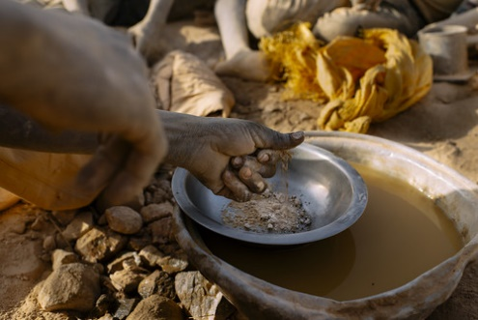

1. Magnetic separation is used in science and everyday life. In a mixture of sand, wood chips and iron filings, **identify** the substance that would be separated using magnetic separation **and describe** the property that makes it suitable for this method. (3 marks)

Iron filings (1) which are metal (1) and will be attracted to the magnet using magnetic force (1) ________________________________________________________________________________________________________________________________________________________________________

1. You have been given a mixture of salty water and need to separate it into water and salt. **State** which separation process you would use and describe what property of water allows this separation technique to work. (2 marks)

|  |
| --- |
| Evaporation (1) water has low boiling point / will turn to gas when heated / will evaporate / any other detailing how water will be separated (1) |
|  |
|  |

|  |  |
| --- | --- |
| **COULD STATEMENT**  Selects and explains the most appropriate separation techniques based on the physical properties of components of a mixture. Explains the difference between pure substances and mixtures with reference to chemical bonds | **COULD QUESTIONS**  21, 22 |

1. Using an **example**, **explain** how the process by which chromatography can separate substances. Draw a diagram to support your answer. (3 marks)

_______________________________________________________________________________________Examples could include, but not limited to: DNA, Covid tests, drug tests, pen ink identification (1) Separates based on the physical properties of the substance (1) such as size of particles, solubility etc. Picture shows the separation of substance (1) ______________________________________________________________________________________________________________________________________________________________________________

**END OF TEST**

**Please check your work!**